College of Arts and Sciences
Division of Natural and Mathematical Sciences

Department of Microbiology

484 West 12th Avenue
Columbus, OH 43210

614-292-2301 Phone
614-292-9120 Fax

September 25, 2017
To: Chair of ASCC
From: Charles J. Daniels, Chair ASCC Natural and Mathematical Sciences Panel

Dear colleagues,

The Natural and Mathematical Sciences (NMS) Panel has reviewed and approved (June 30, 2017) the proposal for the Data Visualization Specialization (DVS) in the Data Analytics major.
The proposed DVS program is the fifth specialization in the Data Analytics major, joining the active specializations in Biomedical Informatics, Business Analytics, Computational Analytics and Social Sciences Analytics. The DVS is a relevant addition to the Data Analytics major and provides students with two complementary skills: students will develop the skills to “visualize data for the purpose of seeing and exploring what is contained within it” and to acquire the ability to make both static and dynamic visuals as a means of “telling the stories found in the analysis of data”. A growing number of job postings in this area support the need for high-level skills in this area.
The NMS panel first considered the DVS proposal on January 31st, 2017; at this time several issues were raised that required further clarification and/or corrections and the proposal was returned for revision without a vote (described below). A revised proposal was reviewed by the NMS panel on April 25th, 2017, and approved with minor contingencies. In response, an updated document was received in June and the proposal was approved in its final form on June 30, 2017.
We had two primary concerns in the initial review:
- The requirements for the specialization were five (3 hour) courses at the 5000-level. The committee was concerned that the focus on higher-level courses might deter students, especially since some of the courses didn’t have prerequisites.
- Of the five required courses, two had not been submitted for approval: ACCAD 5150, “Emerging Trends in Data Visualization” and an ACCAD capstone course.
The remaining questions were less critical and concerned clarifications of learning outcomes and the four-year plan.
These concerns were addressed in the intervening revisions and we formally approved the proposal on June 30th, 2017.

Respectfully,
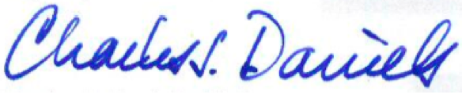

Charles J. Daniels, Ph.D.

