Department of Germanic Languages and Literatures

498 Hagerty Hall
1775 College Road
Columbus, OH 43210-1340

Phone (614) 292-6985
Fax (614) 292-8510

http://germanic.osu.edu

November 27, 2018

To: Meg Daly, Chair of ASCC
From: Carmen Taleghani-Nikazm, Chair of ASCC Arts and Humanities Panel 2

Ref: Approval of revisions to the Andean and Amazonian Studies minor

On October 17, the Arts and Humanities Panel 2 reviewed the proposal to revise the Andean and Amazonian Studies minor in the Department of Spanish and Portuguese (SPPO) in order to update the course offering and recognize the new study abroad program in Pachaysana in Ecuador. The changes to the AAS minor include: a) eliminating courses that are no longer offered or taught, and b) provide clearer guidelines as to when certain courses (based on their contents) can be counted as an elective or core course toward the minor. The revisions will also help SPPO to better exhibit the study abroad program in Pachaysana in Ecuador as an option for completing the minor.

The Panel unanimously approved the revisions to the minor with two contingencies to provide an official cover letter from the Director of Undergraduate Studies or the Chair of SPPO summarizing the requested changes, and to request the Dept of English to take English 4577.03, which is listed on the minor advising sheet, out of limbo. Having satisfied the contingencies, final approval was granted by the chair of the Panel.

Sincerely,

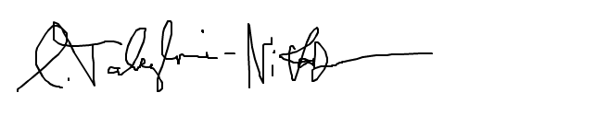

Carmen Taleghani-Nikazm

