College of Arts and Sciences
Division of Natural and Mathematical Sciences

Department of Microbiology

484 West 12th Avenue
Columbus, OH 43210

614-292-2301 Phone
614-292-9120 Fax

October 31, 2018
To: Dr. Meg Daly, Chair of ASCC
From: Charles J. Daniels, Chair ASCC Natural and Mathematical Sciences Panel

Dear Meg,

On October 22, the Natural and Mathematical Sciences Curriculum Committee panel reviewed a proposal to convert the quarter-system Biology BS/DDS to a semester-system equivalent and to include an option for a Biology BA/DDS.

Students enrolled in the program will complete their general requirements for the BS/BA degree during their first three years in the Health Professions track in the Biology program and all general education requirements. In their third year these students will take the Dental Admissions Test (DAT) and apply for admission to the Doctor of Dental Surgery (DDS) program in the College of Dentistry. If admitted, the students will begin the first year curriculum of the DDS program. Upon successful completion of these course requirements the student will be awarded a BS or BA degree and continue in the DDS program.

The Biology BS-BA/DDS program will provide OSU a competitive advantage in recruiting the best applicants as well as lessening the financial burden for these students. The program anticipates an annual enrollment of three students.

The NMS committee made five recommendations; the most notable of these was a request to include an explanation of how students who were unsuccessful in gaining admission to the DDS program could complete their requirements in the Biology program. With these comments the committee voted unanimously to approve the request and the proposal is now advanced to the ASCC with a motion to approve.

Respectfully,
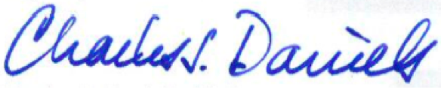

Charles J. Daniels, Ph.D.

