Department of Germanic Languages and Literatures

498 Hagerty Hall
1775 College Road
Columbus, OH 43210-1340

Phone (614) 292-6985
Fax (614) 292-8510

http://germanic.osu.edu

February 28, 2019

To: Meg Daly, Chair of ASCC
From: Carmen Taleghani-Nikazm, Chair of ASCC Arts and Humanities Panel 2

Ref: Approval of revisions to the Islamic Major and new Islamic Minor

On Wednesday, October 31, 2018, the Arts and Humanities Panel 2 reviewed a proposal to create a new undergraduate minor in Islamic Studies and a proposal to revise the existing Islamic Studies major in the Department of Near Eastern Languages and Cultures (NELC). Both proposals are part of the larger ongoing changes to its many programs of studies that NELC has undertaken. Overall, the revisions and new proposals are motivated by the recent changes in NELC faculty, student enrollment, course offerings, and the external reviewer’s feedback.

The current Islamic major is an interdisciplinary program which requires students to take courses in NELC, Religious Studies, CMRS, and History including language courses. The changes to the Islamic major include: a) moving the non-language culture prerequisite to the requirement for the major, b) updating required courses by changing the categories of required courses so that NELC can provide the courses that majors need to graduate, c) allow one cognate elective for the major, to encourage students to take one course toward the major in any of the NELC fields of study, d) revised learning objectives, and e) new program assessment plan.

The panel reviewed both proposals carefully and recognized the effort that was put into the revisions and new proposals. The panel did not vote on that day, however provided the department extensive and detailed feedback on the proposals including the assessment plan (see documents uploaded on the ASC curriculum site). The revised proposals came back to the panel at the beginning of February and were reviewed by Arts and Humanities Panel 2 on Wednesday, February 13, 2019. The panel approved the changes and revisions with contingencies to correct some remaining discrepancies that were found on the advising sheets and in the assessment plan. Having satisfied the contingencies this past weekend, final approval was granted by the chair of the Panel.

Sincerely,

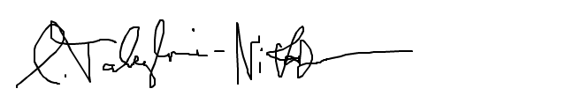

Carmen Taleghani-Nikazm

