**Managing Global Responsibility & Engaged Transformation**

**ARTSSCI 1138.**, First-Year Seminar**

**1 Semester-hour Credit, Fall 2019**

***(Wednesday or Friday)/(mornings)* Room *TBD***

##### Instructor Name: Elliot Bendoly Office Hours: *Fri or Wed 11-1pm*

**e-mail:** bendoly.2@osu.edu

# Course Description

The objective of this first-year seminar is to develop a systems perspective to both professional careers and personal well-being. We will approach this through discussions of decision-making in complex local and global contexts, the understanding of personal strengths and opportunities for growth, and an appreciation of the value that diversity provides in providing responsible solutions. We will explore these topics through the lenses of business practice, insights derived from business research, personal management and hands on experiential activities. Our discussions will consider the challenges and obligations faced by individuals, businesses and the communities they touch. Self-assessments and introspective discussions will be used to connect students to key concepts. By the end of the seminar, students should be able to identify how issues critical to their own well-being, and that of their extended global community, can also serve as guiding principles for industry’s next generation of leaders.

# Texts

All course materials and access to applications will be provided to students in advance.

# Grading

This course will use a Letter or Satisfactory/Unsatisfactory (S/U) grade.

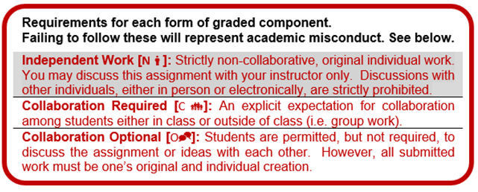

|  |  |  |
| --- | --- | --- |
| Graded components | % of Total | Type |
| Quizzes | 25% | N  |
| Individual Assignments | 25% | N  |
| Group Activities | 25% | C  |
| Participation | 25% | O   |

**Evaluation Criteria: Graded Components**

A final composite score above 80% is considered a Satisfactory grade.

**Academic Misconduct**

**It is the responsibility of the Committee on Academic Misconduct to investigate or establish procedures for the investigation of all reported cases of student academic misconduct. The term “academic misconduct” includes all forms of student academic misconduct wherever committed; illustrated by, but not limited to, cases of plagiarism and dishonest practices in connection with examinations. Instructors shall report all instances of alleged academic misconduct to the committee (Faculty Rule 3335-5-487). For additional information, see the Code of Student Conduct**[**http://studentlife.osu.edu/csc/**](http://studentlife.osu.edu/csc/)**.**

**Purpose of the First Year Seminar**

The purpose of this seminar is to provide first year students with faculty-lead introductions to contemporary topics spanning the multiple management disciplines. Lessons are simultaneously designed to demonstrate the broad applicability of findings at the frontier of research into systems thinking, as it informs responsible decision-making; affording attention to the impact of business decisions on the environment, communities, and individual well-being. Frameworks for capturing the system dynamics of contexts in which decision-making is done will be presented and used. My own tools for visualizing system dynamics, as will a management framework that I have adapted for thinking through cause and effect, lags and feedback loops, processes and risk.

These discussions are also intended to provide students with an understanding of themselves, where their strengths lay, where their implicit biases may exist, how to grow and develop as individuals, and best practices in areas such as personal finance and time-management with an eye on reducing exposure to stress, appropriately thinking about risk and increasing adaptation to change. These efforts will be assisted through self-assessment activities, but will also be folded into discussion about how managers and organizations deal with these matters (or could benefit from doing so better).

In short, as students progress through the seminar, they gain an understanding of the value of various scholarly perspectives, while benefiting from frameworks and skills that can serve them both in life and in their academic careers. The aim is for all students enrolled in this seminar, to both subsequent coursework, personal management and career objectives as thoughtful decision-makers and responsible global citizens.

**Readings**

Critical to our in-class discussions and activities will be pre-class readings. As a scholar in the Management Sciences, with over 50 peer reviewed articles, and numerous research awards and textbooks on human behavior, management visualization and enterprise technology, I’ve learned to appreciate the importance of systems thinking, and the threat that narrow perspectives create. As such, systems thinking will serve as a thread across our discussions and our selected readings.

Throughout the term, we will consider findings from my own work, and I will be able to expand directly on the work and implications. However, we will also consider critical contributions by other researchers across multiple domains, as we transition to other topics during the term. Many of these research colleagues also hold faculty positions in other departments at The Ohio State University. I have worked with them in the past and I am confident they will be willing to provide additional insights.

I will provide access to all reading in advance. The following reading list will be **supplemented with the discussion of current events, with postings in the 5000-member International Business Ethics forum that I manage on LinkedIn.**

[Week 1] Bendoly, E. 2016. Incomplete Pictures / Coping with Haystacks. In E. Bendoly and S. Clark, Visual Analytics for Management: Translational Science and Applications in Practice, Taylor & Francis / Routledge, London. 85-99.

[Week 2] Sterman, J., Oliva, R., Linderman, K., Bendoly, E. 2015. System Dynamics perspectives and modeling opportunities for research in Operations Management, *Journal of Operations Management* 39/40, 1-5.

[Week 3] Freel, D.E. (2013) Building Ethical Capital – Is Perception, Reality? Public Administration Review Journal review. Vol. 73, Issue 2, 263-264.

[Week4] Foraker, R., Mann, D., Payne, P.R.O. 2018. Are Synthetic Data Derivatives the Future of Translational Medicine? JACC Basic to Translational Science. 3(5), 716-718.

**[Week 5] Braumoeller, B.F. 2008. Systemic politics and the origins of Great Power conflict. American Political Science Review. 102(1), 77-93.**

**[Week 6] Chen, Y., Jayaprakash, C., Irwin, E. 2012. Threshold management in a coupled economic-ecological system. *Journal of Environmental Economics and Management*. 64(3), 442-455.**

**[Week 7]** Sommer, S., Bendoly, E. Kavadias, S. Ambiguous problem complexity, group synergy and performance: an experiment. Forthcoming in *Management Science*.

[Week 8] Braun, E., 2016. Framing wicked problems using co-design and a hybrid design toolset. In E. Bendoly and S. Clark, Visual Analytics for Management: Translational Science and Applications in Practice, Taylor & Francis / Routledge, London. 85-99.

[Week 9] Hood, A., Bachrach, D., Zivnuska, S., Bendoly, E. 2016. The mediating effects of psychological safety in the relationship between team affectivity and transactive memory systems. *Journal of* *Organizational Behavior,* 37(3), 416-435*.*

[Week 10] T. Schoenherr, E. Bendoly, D. Bachrach, A. Hood. 2017. Task interdependence impacts on reciprocity in IT implementation teams: Bringing out the worst in us, or driving responsibility? *Production and Operations Management,* 26(4), 667-685.

[Week 11] R. Hardcopf, P. Goncalves, K. Linderman, E. Bendoly. 2017. Short-term bias and strategic misalignment in operational solutions: perceptions, tendencies and traps. *European Journal of Operational Research,* 258(3), 1004-1021.

**[Week 12] Staley, D.J. 2014. *Reconfigure. Brain, Mind and Internet: A Deep History and Future*. Palgrave Pivot, New York. 15-28.**

[Week 13] Bendoly, E. 2014. Systems dynamics understanding in project execution: information sharing quality and psychological safety, *Production and Operations Management* 23(8), 1352–1369.

**iPad Activities**

**Students will be installing the iLeaf suite of activities from the OSU Self-Service interface on their issued iPads. This suite contains a number of hands on activities, in a variety of systems contexts that we will be discussing. Below, clips are provided of a sustainable supply chain activity and of a evidence-based leadership activity, both components of the iLeaf suite. We will also be accessing self-assessment surveys, feedback summaries and tutorials using these devices. Students are expected to bring iPads each session.**

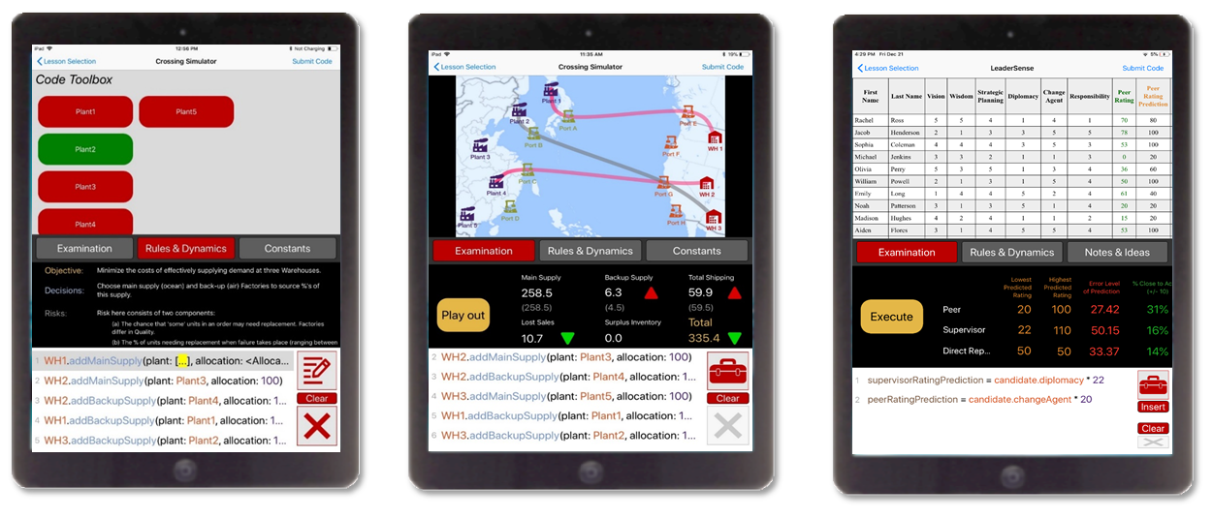

*Graded components in detail*

***Quizzes*** *(* N*):* A total of 5 quizzes will take place during the course of the semester. These will vary in format, and in some instances may involve the use of some technology component accessible on student iPads. Study notes for each quiz will be provided in advance by the instructor. Quizzes are strictly individual efforts. Students found to be working with others in any way during the quiz, sharing or receiving quiz question or answer information with others, or using resources (even with Lock Downs active) outside of that which is allowed will be reported to COAM. Each of the quizzes will focus on one of the topics covered in the prior weeks of the course, and will require students to demonstrate the connection between content discussed, career goals and the value of developing a multi-disciplinary perspective.

***Individual Assignments*** *(* N*):* Similar to quizzes, individual assignments may not involve student collaboration but will often involve the use of available student course technology. Over the course of the term, there will be four individual assignments, designed along with group activities and in-class discussions to dive into specific topics and bridge weekly discussions. These activities may vary from the development and interpretation of guided self-assessments to the solution of problems characteristic of career-related challenges.

***Group Activities*** *(* C *):* Group activities are formal small group tasks that have a specific objective in mind. These are in contrast to the occasional use of less formal small group discussions in class. These activities will each involve the use of student course technology to collaboratively develop solutions to problems, which will subsequently be incorporated into class discussions. In group activities, individuals are expected to each play a role, and each have the opportunity to evaluate the contributions made by others. These peer evaluations will be shared with the instructor. There will be two group activities in the semester. Group membership may be entirely different between the two activities.

***Participation*** *(* O *)***:** For all small group discussions and activities, as well as individual in-class work, students are expected to fully participate in the work at hand. Work on other coursework during these times, browsing the internet for personal purposes, gaming, etc. is not be permitted. In the case of individual in-class work and participation in the lecture, instructors will base participation grades off of contributions to discussion. In the case of participation in group work, individual students will have the opportunity to provide peer evaluations and submit these to the instructor for consideration.

**Course Policies**

*Attendance:*

Students are expected to attend all sessions, bringing with them their University issued iPads. Excused absences must be cleared with the instructor a week in advance. Any student who fails to attend without giving prior notification to the instructor will be dis-enrolled after the third instructional day of the term, the first Friday of the term, or the second scheduled class meeting of the course, whichever occurs first.

*Technology Policy:*

Students must come to class sessions with OSU issued iPads. However, students are expected to be attentive to instructor and group discussions, and reserve the use of these devices to designed application activities and note-taking.

*Testing and Late Submission Policy:*

Missed quizzes can only be made-up in extreme cases (e.g., death of family member, personal hospitalization, etc.) with proper documentation (e.g., a physician’s note, ER paperwork, obituary, etc.). Each decision of potentially allowing a make-up quiz is made by the instructor on a case-by-case basis. Additionally, you MUST contact the instructor as soon as you know of a potential problem or conflict with an exam date. Alternative methods (e.g., oral exam, essay) of testing may be used for make-up quizzes. If you are experiencing an extreme situation or emergency, please attempt to notify the instructor email ASAP.

Late submission of individual or group work will result in reduced point values. Submissions that are one hour late will result in a 5% reduction of total points. Those that are later than one hour, but within 24hrs of submission will see a 20% point reduction. Submissions that are between 24-48hrs late will see a 40% point reduction. No submissions will be accepted after this point in time. The same rule applies to group work submissions. The intention of this policy is to ensure continuity in discussions in feedback, for the benefit of the class as a whole.

**Students with Disabilities**

**Students with disabilities (including mental health, chronic or temporary medical conditions) that have been certified by the Office of Student Life Disability Services will be appropriately accommodated and should inform the instructor as soon as possible of their needs. The Office of Student Life Disability Services is located in 098 Baker Hall, 113 W. 12th Avenue; telephone 614- 292-3307,**[**slds@osu.edu**](mailto:slds@osu.edu)**;**[**slds.osu.edu**](http://slds.osu.edu/)**.**

**Biographical Statement**

**Dr. Elliot Bendoly is Fisher College of Business Distinguished Professor in the Management Sciences, at the Ohio State University. He holds the title Operations Management Distinguished Scholar at the Academy of Management, and was the Caldwell Research Fellow at Emory University. He has 55 peer reviewed articles (h-Index of 29, Scopus). He is the author of six texts including “The Handbook of Behavioral Operations Management”, “Visual Analytics for Management” (www.ma-vis.com) and “Excel Basics to Black Belt, 2nd Edition” (www.excel-blackbelt.com). His LinkedIn discussion forums, “Excel Basics to Blackbelt”, “Operations Management in Practice”, and “International Business Ethics”, boast 28,000+, 22,000+ and 5000+ members respectively.**



