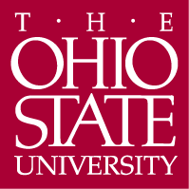

Department of Germanic Languages and Literatures

498 Hagerty Hall
1775 College Road
Columbus, OH 43210-1340

Phone (614) 292-6985
Fax (614) 292-8510

http://germanic.osu.edu

April 16, 2019

To: Meg Daly, Chair of ASCC
From: Carmen Taleghani-Nikazm, Chair of ASCC Arts and Humanities Panel 2

Ref: Approval of proposal for a Certificate in Translation and Interpretation

On Wednesday, March 20, 2019, the Arts and Humanities Panel 2 reviewed a proposal to create a new Certificate in Translation and Interpretation as well as requests for new courses in Center of Languages, Literatures and Cultures (CLLC) 5100, 5102, and 5103. The proposed cross-departmental certificate offers Ohio State undergraduate students with advanced second language and intercultural skills a unique opportunity to earn an additional credential that will add high-demand skills to their education in languages, literatures and cultures.

The certificate proposal was developed by faculty members from a consortium of departments including Departments of East Asian Languages and Literatures (DEALL), Spanish and Portuguese (SPPO), Germanic Languages and Literatures (GLL), French and Italian (FRIT), Comparative Studies (CS), Slavic and East European Languages and Cultures (SEELC), Linguistics, and English. The program consists of twelve credit hours. Students will take one of the three credit hours new courses CLLC 5100, CLLC 5101 and CLLC 5102 and the new CLLC 5103 (three credit hours). Students will complete the certificate by taking six credit hours of coursework in their working languages. Undergraduate majors, second majors, and minors in the language departments will be ideal candidates for the program, but students in all majors with relevant coursework in a language other than English are also welcomed. The new certificate’s goals and objectives are the following: a) Students will demonstrate theoretical knowledge related to the practice of translation and interpretation; b) Students will demonstrate understanding of the profession of translation and interpretation and apply professional ethics in the application of these skills, and c) Students will gain supervised practical experience in the field of translation and interpretation under the guidance of highly qualified faculty members.

The panel agreed that the proposed new certificate offers students the opportunity to enhance their advanced language skills and make them more marketable when seeking employment. The certificate was unanimously approved by our panel with few contingencies, which have been satisfied. The panel also unanimously approved the new course request CLLC 5103 with contingencies, which have also been resolved, while the other three new courses were unanimously approved with no contingencies. We now advance the certificate and new course proposals to the Arts and Sciences Curriculum Committee with a motion to approve.

Sincerely,

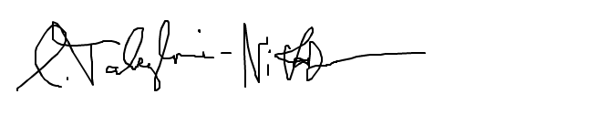

Carmen Taleghani-Nikazm

