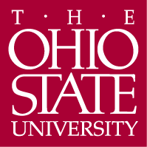

Department of Germanic Languages and Literatures

498 Hagerty Hall
1775 College Road
Columbus, OH 43210-1340

Phone (614) 292-6985
Fax (614) 292-8510

http://germanic.osu.edu

January 30, 2020

Associate Professor Alison Crocetta
Chair, Arts and Sciences Curriculum Committee

Re: Approval of combined BA/MA in French and Francophone Studies

Dear Alison,

On October 24, 2019, the Arts and Humanities Panel 1 of the ASCC reviewed a proposal for a combined BA/MA in French and Francophone Studies. This new program seeks to retain the program’s strongest undergraduate French majors through the MA and to provide them the opportunity to complete two degrees in only 5 years. In addition, the department’s goal is to create a revenue-generating program by increasing their overall number of students in their 5000-level and above courses.

The panel agreed that the proposed combined BA/MA offers an additional option for students in French major and for faculty who teach in the major. The panel, however, had a few questions and points regarding some aspects of the proposal which were forwarded to the department. On January 14, 2020, the panel reviewed the revised proposal and agreed that all points had been addressed. The revised proposal for a new combined BA/MA in French and Francophone Studies was then unanimously approved with no contingencies. We now advance the proposal to the Arts and Sciences Curriculum Committee with a motion to approve.

Sincerely,
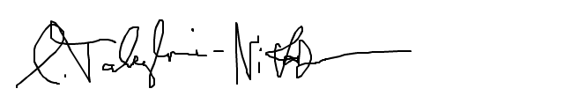
Carmen Taleghani-Nikazm
Professor
taleghani-nikazm.1@osu.edu

