College of Arts and Sciences
Division of Natural and Mathematical Sciences

School of Earth Sciences

275 Mendenhall Labs
125 S Oval Mall
Columbus, OH 43210

Phone (614) 292-6290
E-mail panero.1@osu.edu

December 1, 2020
To: Chair of ASCC
From: Wendy Panero, Chair ASCC Natural and Mathematical Sciences Panel

Dear colleagues,

The Natural and Mathematical Sciences (NMS) Panel has reviewed and approved (November 19, 2020) a proposal for a combined Microbiology BS/MS degree.
The proposed combined BS/MS program in Microbiology enables high-performing Microbiology BS students to earn an MS in a fifth year of enrollment. This program enables students to complete the requirements for their undergraduate degree as well as coursework for an MS degree in five years on either a thesis-based or non-thesis MS plan. This program will require that students achieve the goals of both programs, with application for admission to be completed in the students’ third year. A growing number of graduating Microbiology students (~25%) take a “gap year” after graduation in preparation for professional schools. This program is designed to capture some of these students and will therefore likely attract 4-6 students per year.
The NMS panel first considered the program proposal on August 26, 2019; at this time several issues were raised that required further clarification and/or corrections and the proposal was returned for revision without a vote (described below). A revised proposal was reviewed by the NMS panel on November 15, 2020 and approved with minor contingencies. In response, an updated document was received, and the proposal was approved in its final form on November 19, 2020.
We had one primary concern in the most recent review:
- The assessment plan needed to clearly lay out how students meet the program goals for the BS and MS independently, and how those goals are met by students completing a non-thesis MS degree.
The remaining questions were less critical and concerned clarifications of learning outcomes and the five-year plan.
These concerns were addressed in the intervening revisions and we formally approved the proposal on November 19, 2020.

Respectfully,
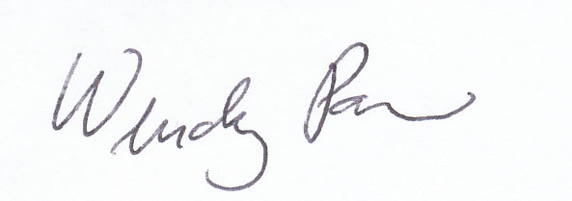

Wendy Panero, Ph.D.

