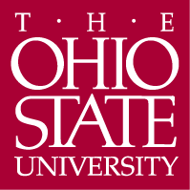

Department of Germanic Languages and Literatures

498 Hagerty Hall
1775 College Road
Columbus, OH 43210-1340

Phone (614) 292-6985
Fax (614) 292-8510

http://germanic.osu.edu

February 27, 2020

Associate Professor Alison Crocetta
Chair, Arts and Sciences Curriculum Committee

Re: Approval of a new MA in Russian Language and Culture for the Professions

Dear Alison,

On Thursday, September 26, 2019, the Arts and Humanities Panel 1 of the ASCC reviewed a proposal to create a new MA program in Russian Language and Culture for the Professions.

The aim of this program is to provide MA students with the opportunity to focus on applied Russian language knowledge and to develop high level language proficiency skills. In so doing, students in this MA program will be prepared for the increasingly demand for experts in Russian language and culture in government and private sector jobs. The proposal was well received by the panel. The panel members agreed that this program will contribute to the national needs and unanimously approved it with two contingencies and one recommendation, which have been resolved. We now advance the proposal to the Arts and Sciences Curriculum Committee with a motion to approve.

Sincerely,
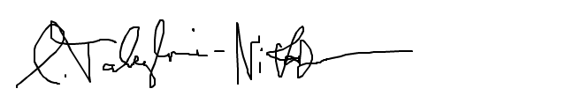
Carmen Taleghani-Nikazm
Professor
taleghani-nikazm.1@osu.edu

