The Ohio State University
First-Year Seminar Program
Course Proposal

Course Information

- Attach a syllabus that includes the following (sample syllabi can be found at http://firstyearseminars.osu.edu):

- the course goals
- a brief description of the content
- the distribution of meeting times
- a weekly topical outline
- a listing of assignments
- grade assessment information (A-E or S/U)
- required textbooks and/or reading list
- the academic misconduct and disability services statements (sample statements can be found at
http://asccas.osu.edu/curriculum/asc-syllabus-elements)

Instructor Information
- Attach a brief biographical paragraph that includes the current research interests, teaching awards and honors, and undergraduate courses taught by the participating instructor(s).

Linda Mizejewski, WGSS

Proposer’s Name and Primary Academic Unit (please print)

What’s Love Got to Do With It?: Women, Men, and Romance

Proposer’s Title

Mizejewski.1@osu.edu

Proposer’s e-mail Address

Submission Date: Jan. 19, 2022

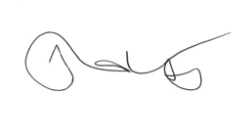Shannon WInnubst, Chair, WGSS

Approval of Department Chair of Academic Unit (please print)

Please return this form and any attachments to Todd Bitters, bitters.4@osu.edu, no later than MARCH 1.

1/28/2021 tab

