Department of English

421 Denney Hall
164 Annie & John Glenn Ave.
Columbus, OH 43210

614-292-6065 Phone
614-292-7816 Fax
english.osu.edu

February 27, 2023

Dear Vice Provost Smith,

The English Department is proposing to make small changes to the English Minor:

- The English Minor currently requires 15 credit hours, and we would like to reduce this to 12 credit hours. This reduction will put us much more in line with our peers: Asian American Studies, Classical Humanities, History, and Women’s, Gender, and Sexuality Studies all have minor programs consisting of 12 credit hours.
- We would like to add new courses developed for the GEN to our writing requirement portion of the minor.

Included is the current minor program form with the requested changes made in tracked changes in margins. We would like to implement the proposed changes in Autumn 2023. Current students in the minor would be grandfathered into the new program requirements at the time of implementation.

On behalf of the Department of English, thank you for your consideration.

Sincerely yours,

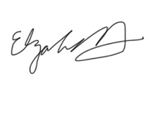
Elizabeth Hewitt

